Budget Tracker

Assume Antra has a client, which needs an application to track its budget. Application must be developed with technologies Angular, .Net Core Web API, Entity Framework Core, SQL Server Database. Clients’ needs the following operations in the application.

# Users: -

Should be able to Add/Update/Delete/List the Users.

# Income: -

Should be able to Add/Update/Delete/List the Income.

# Expenditure: -

Should be able to Add/Update/Delete/List the Expenditure.

Below is the database design for the application. All primary keys should be automatically incremented value.

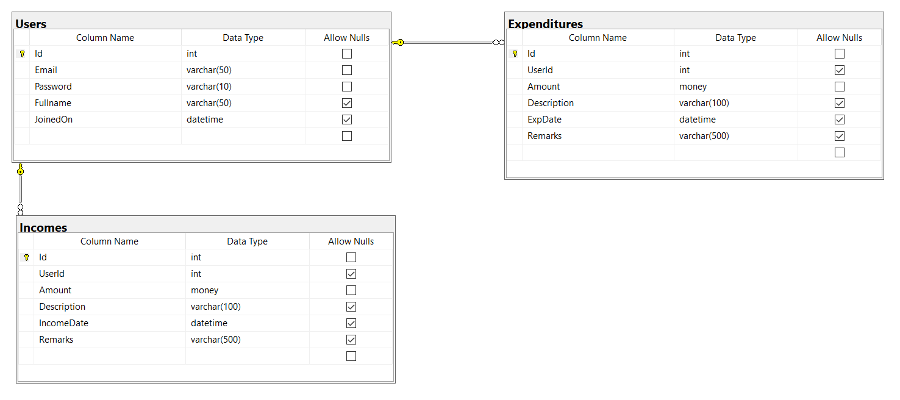

Guidelines:

1. Design the UI in Angular (Bootstrap 4 and ngBootstrap). Show all the users as table and Username should be clickable, that should go to User details where they will show Users Income and Expenditures.
2. Create Database with EF Core Code First approach using migrations (Have at least 20 users with each user having at least minimum of 2 incomes and 5 expenditures)
3. Connect with the database using Entity Framework Core. (Use Best practices architecting your application)
4. Should use Dependency Injection
5. Write the business logic in services using ASP.Net Web API Core.
6. Test the API with Postman

# Deadline of the assignment

Finish your assignment in a day. Upload your code in Github with database script and share the link.